**CICD EXPERIMENT – 4**

**Static code analysis using Sonarqube**

1. Visit **sonarqube.org/download** and download sonarqube

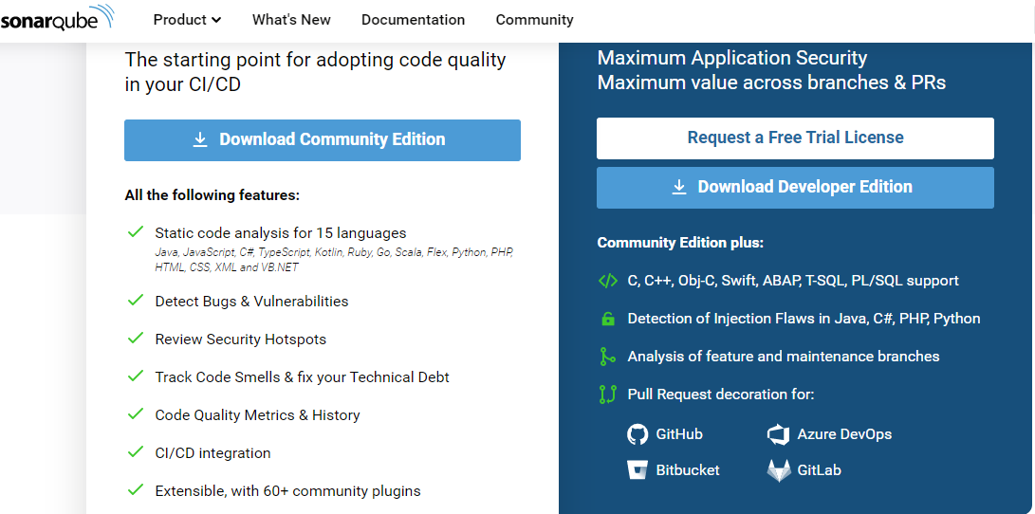

1. Extract the zipped folder which is downloaded. In the extracted folder, go to bin, then to Windows-x86-64(if using windows as OS) and copy the path of the folder

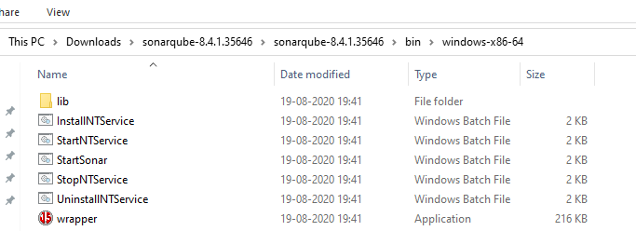

1. Open command prompt and move to the copied location. Type the command “StartSonar.bat” to start sonarqube

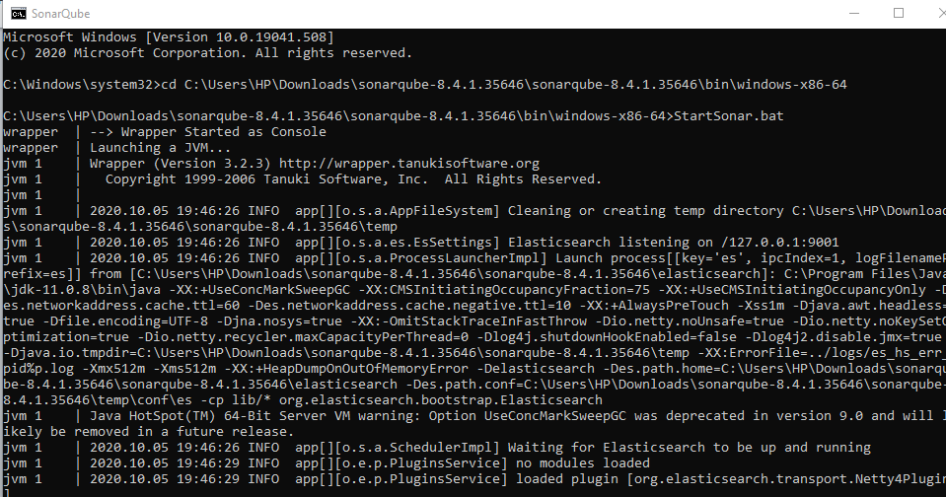

1. Now open “localhost:9000” in a web browser and enter the credentials

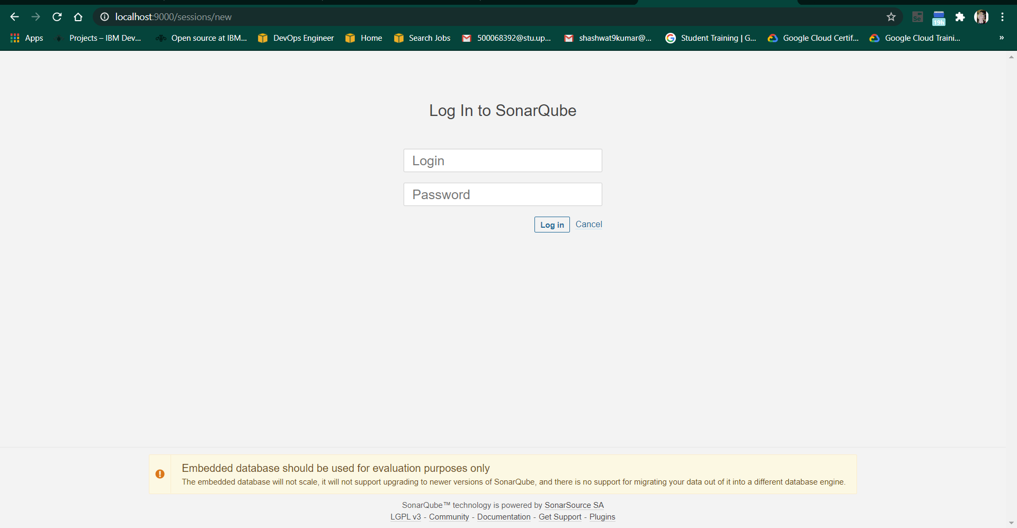

1. Change the directory to the Maven project whose code quality is to be accessed and run the command “mvn clean install sonar:sonar -Dsonar.host.url=http://localhost:9000 -Dsonar.analysis.mode=publish” in cmd
2. Some dependencies would be downloaded and a build successful message would appear

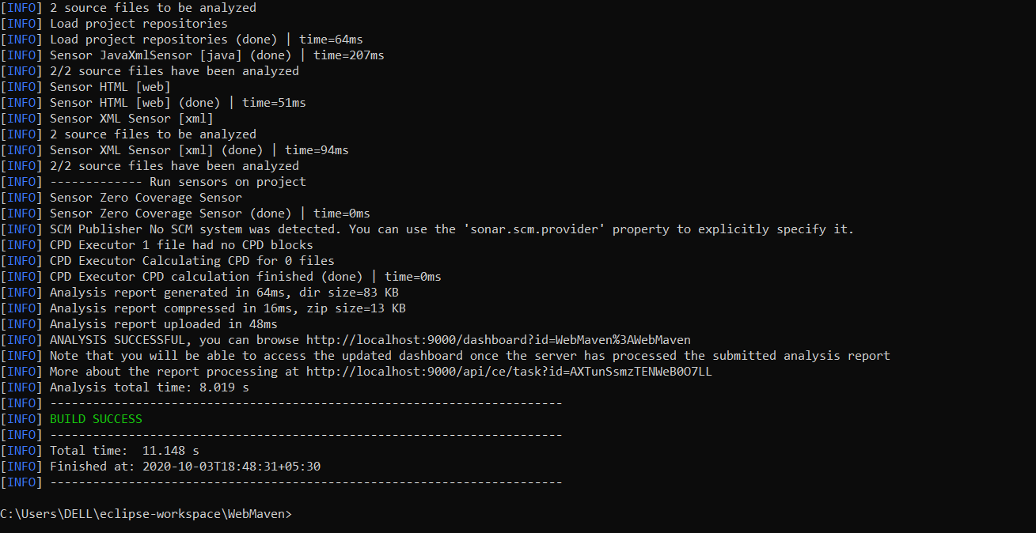

1. At http://localhost:9000/projects, you will find your maven project and vulnerabilities will be accessed

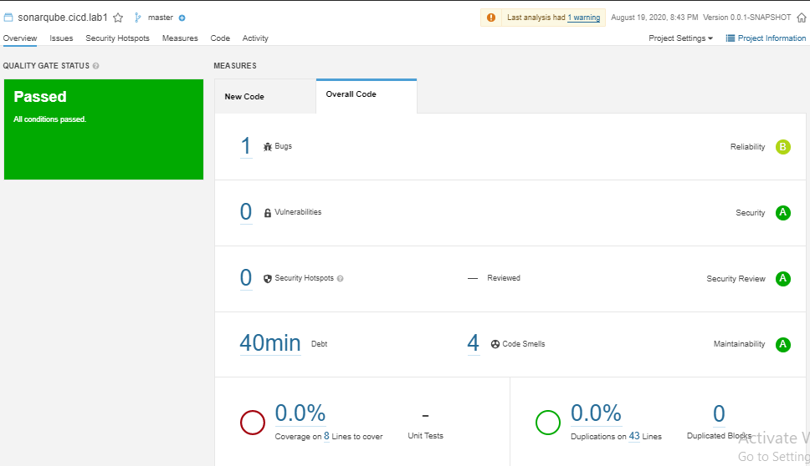

ATISHAY JAIN

500067694

R171218030

CSE, DEVOPS